professional and personal growth of women educators and e
xcellence in education.

Leading Women Educators Impacting Education Worldwide (Vision)

2018-2020 Officers
President Connie Voss
First Vice President Karen Ball
Second Vice President Cathy Curtis
Recording Secretary Julie Frank
Corresponding Secretary Mary Taylor
Treasurer Cathy Curtis
Parliamentarian Chris Berto
Webmaster Mary Jane Sterling
Newsletter Editor Dorothy Dean
Websites: www.dkg.org
www.deltakappagamma.org/IL/
Nu Chapter’s website: www.nuchapterdkg.weebly.com

A Note from the President
As I sit here, there is bright sun streaming in my front window. Even though it is still cold outside, I can feel the warmth from across the room. It is a welcome shock to the system! We certainly have not had enough sun, and warmth, this winter. Perhaps, though, there is an upside to this cold and dreary winter that we have had. While we might have stayed indoors more, been less active, and maybe even went to bed a bit earlier, it might have given us a chance to “recharge our batteries” and be ready to take advantage of all that is ahead.
Even more significant than the official first day of spring might be the switch to daylight savings. Can you believe it is this coming Sunday (as I write this), March 10, that daylight savings begins?! There’s hope for a bright future! Darkness will not fall so early each day, sparking some hope and renewed energy in each of us. Spring, and then Summer beyond, will actually come!
As Nu Chapter sisters, we have much to look forward to today. Our near future is a busy time and we are ready for it. Soon we will meet to discuss this year’s Big Read Peoria Reads book for our March program, and we are fortunate to have our own Roberta as discussion leader and chair of Peoria Reads. Coming up in April are the Annual Coordinating Council luncheon/meeting and the Lambda State Convention—worthwhile events that are open to anyone who would like the opportunity. In May, we will already start planning for next year. These are just a small sampling of what is ahead.
I wish you each some new pleasures in the warmth of the sunshine!
Take care, Connie

Membership Committee
Recommendations for membership may be submitted at any time to the Membership Committee or an officer.
Need a Ride???
If you would like to attend a meeting and would like a ride but don’t know who to call, please contact any of the officers (telephone or email), let your phone tree caller or an officer know, and/or reply in your email response.

Please Respond
A reminder to return calls/voice messages, text messages, and/or emails whether or not you’ll be attending a meeting.

Have You Been Thinking?
Delta Kappa Gamma has the opportunity each year to help young ladies in their teacher education. Please share names of those you think may qualify.
2019 Lambda State Convention
Think about joining the Chorus or Instrumental Ensemble for the convention April 26-28, 2019, at the Decatur Conference Center and hotel in Decatur, Illinois.
Illinois (Lambda) State Slate, 2019-2021
The slate of officers for the new biennium are:
President Beverley Johns
1st Vice-President Dr. Joan Rog
2nd Vice-President Linda Adcock
Recording Sec. Dr. Margaret Trybus
Corresponding Sec. Pamela Painter
Nu Chapter members can also play a role in the new biennium activities by serving on a State committee. You can download a committee recommendation form from: nuchapterdkg.weebly.com, Documents and Links, Nominations Committee or contact Mary Jane Sterling, who can send you a form.

Nu’s Dues News
What??? It’s time to pay dues again already??? Well, not quite, but…
DKG International has changed the schedule so dues for the next year are now due on June 30. Our Finance committee is meeting in April to craft a budget. They expect (but it’s not certain until we vote in May) that dues will be $96 again. There is money in the account raised from selling Bergners coupon books so the committee expects to offer a dues relief. The amount hasn’t been determined yet but it has been $20 the past few years.
If paying dues twice in 8 months is awkward for your budget, please don’t hesitate to talk to Cathy Curtis, our treasurer (692-5078 or c.curtis@pndhs.org). Together you can work out a payment schedule that is good for you.

It’s Showtime!
Upper Bradley Park… Saturday morning in May… visiting with your Nu sisters… What could be better?
Laura Johnson, actress, director and former Nu member, will present It Plays in Peoria, 100 Years of Community Theater in Peoria on May 4 at 10:00 a.m. (See Yearbook page 30)
Local community theaters’ costume departments would welcome our donations of vintage accessories – purses, gloves, hats – as well as safety pins, buttons, and clear, plastic storage boxes.
Please join us for the last meeting of the year before our summer break. It’s guaranteed to be a hit!

Coordinating Council
Joint Meeting
You Are All Invited!
All Nu Chapter members are invited to the Annual Peoria Area Coordinating Council Luncheon to be held on April 6. The Coordinating Council is made up of representatives from Beta Zeta, Alpha Lambda and Nu Chapter who meet at least a couple times a year in order to coordinate new members list and activities. Julie Frank and Connie Voss are the current Nu Chapter representatives. Our annual event, which is Saturday, April 6 this year, is an opportunity to socialize with our fellow area DKG members and enjoy a worthwhile program. The $20 fee charged pays for lunch and is to be paid to our treasurer, Cathy Curtis, who will write one check for our chapter payment.
What: Annual Peoria Area Coordinating Council Annual Meeting
Where: Barrack’s Cater Inn, 1224 W. Pioneer Parkway, Peoria
Time: 9:45 a.m. registration; 10:15 a.m. brunch; 11:00 a.m. speaker followed by short business meeting
Menu: Quiche, fruit, assorted rolls, coffee and tea
Program: Family House, Laura Blackaby, Executive Director
Cost: $20 per person, payable to each chapter treasurer
Reservations: Due to Julie Frank by March 29
Contribute your used books/dvd’s/movies to the used book sale that day; however, please retrieve any leftovers that belong to you at the end.

If you know of someone who needs our attention, please let one of the officers know.
Heart-Healthy Recipes
Even though our February meeting was cancelled, we’re still following through on a collection of “heart healthy” recipes. We’ve started a collection of recipes sent in by chapter members and will add to the collection as more come in. All of these will be made available in a printed form at a later time – and you can access them immediately through our Website: http://nuchapterdkg.weebly.com. Go to the More tab and scroll down to recipes. Do you have a recipe to share? Please send it to Mary Jane: sterling@bradley.edu or send a copy to her home address.

Apply for a Stipend!
Did you know that any member may apply for a Lambda State Foundation stipend? These applications do not have to be initiated by the Chapter. Stipends are awarded to individual members for individual projects.
These projects can be inside the classroom or somewhere in the community (such as Common Place) and can involve the individual member, not necessarily the chapter.
Look under Foundation on the Lambda State Website, and you’ll see a listing of stipends awarded. Applications for the Foundation stipend are due on May 1 and November 1.
A complete listing of all Scholarships, Stipends and Grants is found on our chapter website (nuchapterdkg.weebly.com site). Guidelines and application available on Lambda State website.

2018-2019 Yearbook Updates
Chris Berto
You may wish to make these corrections to your yearbooks:
Page 10
Honorable J.B. Pritzker (D)
Phone 217-782-6830 or 217-782-6831
Delete Fax
Email: GovernorsOffice@illinois.gov

Page 58
Add to 2019
June 28-30
40th Anniversary Creative Arts Retreat
Allerton Park, Monticello, IL

If you see information in the yearbook that needs correcting or updating, please contact Chris Berto: call/text 309-688-4282 or email cab3908@gmail.com. Updated yearbook information will appear in Nu’s Notes.

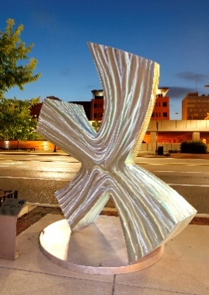
Sculpture Walk Cards
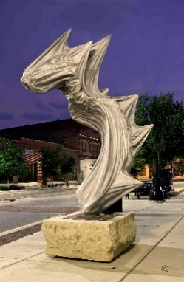
A huge thank you to our artist/photographer-in-residence, Jeanette Kosier, for her generous contribution of pictures for the Sculpture Walk cards. Members purchased the cards at the December meeting, the Arts Partners purchased some for their correspondence, and the Peoria Riverfront Museum purchased the rest for sale in their gift shop. Classy, classy! Thank you, again, Jeanette!

Common Place Donations
As of February 26, 2019
- 10 notebooks
- 5 spiral notebooks
- 20 pens
- 60 colored pencils
- 21 pencils
- 49 erasers
- 18 pens
- 6 tubs disinfectant wipes
- Incentive gift
- 20 zip lock bags
- 1 box Kleenex
- 1 computer with monitor
- 4 Wooden puzzles – alphabet
- 7 Felt tip markers
- 17 Scissors
- Hole punches
- Wooden numbers - place value
- 2 Floor puzzles
- 50 Place value blocks and tiles
- Paint set (palette and brush)
- Stapler
- 8 Rulers
- 300 Colored pencils
- 40 Pencils
- 2 Writing tableus
- 1 Spiral notebook
- 1 Composition book
- 20 National Geographic magazines
- 2 Large boxes of worksheets
- Book on Working with Pentaminoes
- Set of plastic Pentaminoes
- 14 plastic pencil/pen boxes
- set of wooden "two letter sounds" cards
- 24 packs flash cards
- Flags of countries
- Letters of alphabet puzzles
- US puzzle
- 7 clip boards
- Fractions 1/11 - 1/20 plastic in box
- 2 boxes wooden cylinders

Past Meeting Minutes
NU Chapter (#13) General Membership Meeting,
December 1, 2018
To Be Approved at the March 13, 2019
General Business Meeting
Call to Order President Connie Voss called the meeting to order at 10:20 a.m. at Common Place followed by the recitation of A Collect for Teachers. A quorum was present with 12 members in attendance.
Recording Secretary Minutes of the November 12, 2018 meeting were approved as printed.
Treasurer’s Report The treasurer’s report to be filed for financial review was as follows:
Checking Account Balance as of November 12, 2018 $591.77; Income $0.00; Disbursements $460.00 ($60 Lambda State Convention & Leadership Training Fees, $400.00 Marion Medical Mission); Checking Account Balance as of December 1, 2018 $131.77; CEFCU Savings $32.22; CEFCU Money Market account (+$2.11 interest) $7,593.44; Total Balance December 1, 2018 $7,757.43.
Communications and Publicity The December edition of Nu’s Notes was distributed electronically and at the meeting with the remaining copies being mailed or delivered by members. Yearbook updates appeared in Nu’s Notes. Cam Ratcliff attended the November meeting of Women’s Civic Federation and shared details on the Election Commission.
Educational Excellence Nu Chapter’s next meeting is February 1, 2019 at Hult Health Center. Mary Jane Sterling is collecting “heart healthy” recipes from members and will make a recipe book. Members are encouraged to wear red.
Professional Advancement and Outreach Old Business The deadline for applications for state scholarships, stipends, grants, and awards is February 1, 2019. Monetary donations for additional wells were rewarded with candy and bottled water. Carol Sleeth reported that Common Place is working with Jobs for Life, a faith based 8-week program, designed to help adults find and retain employment and that 10 people recently completed the program which assigns a mentor to each participant. Additional mentors are needed, and St. Paul Baptist Church has helped monetarily. Shirley Dresden reported that members had read 121,800 minutes by the November meeting for a total of 6,154,860 minutes. Five Nu chapter members attended Side By Side at Mary Jane Sterling’s home and worked on hats for newborn babies at local hospitals.
Old Business DKG puzzle books will be printed by EP!C for approximately $1 per copy and will be sold at state convention. Packets of 5 envelopes and cards with photographs by Jeanette Kosier will be sold at the Riverfront Museum for $10 and at Nu Chapter meetings for $7.50. State ambassador Sue Dion will attend the March 13th meeting and currently receives Nu’s Notes electronically.
Adjournment The meeting adjourned at 11:00 a.m.
Program Members made ornaments to be donated to Peoria Dream Center and Common Place. A potluck luncheon followed.
Julie Frank, Secretary
Connie Voss, President

If you would prefer to receive an electronic version of Nu’s Notes, please email Dorothy Dean at ddean@icc.edu to be included in an electronic distribution list.
If you would like to post news in an upcoming issue of Nu’s Notes, send your information to Dorothy Dean ddean@icc.edu or 309-694-5316.

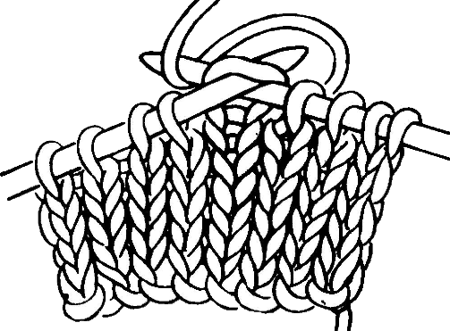
Side by Side
Everyone is a Welcome!
(See Yearbook page 31)
The Women in the Arts Committee is promoting a Side by Side program of crafting, sharing, and socializing. This time has been set aside to be together enjoying our hand crafts and each other. Projects will include teaching each other to knit, crochet, cross-stitch, etc. Bring your own project, craft, and food. If you don’t have a craft that interests you now, come and socialize.
Crafting, knitting, sharing, and caring
- Thursday, April 4, 2019, 5:00 p.m. to 7:00 p.m., location to be determined
- Thursday, May 16, 2019, 5:00 p.m. to 7:00 p.m., location to be determined

Celebrating 40 years of the Women In The Arts
Creative Arts Retreat
“Somewhere Over the Rainbow in Ruby Slippers”
Calling all DKG Sisters, whether you are an artist or not, to join us in celebrating 40 years of the Arts at the Creative Arts Retreat.
New Summer Retreat Date:
June 28-30, 2019
New Central Location: Allerton Park in Monticello, Illinois
https://allerton.illinois.edu/
New Program Features: Talent Show, Art Gallery Showcase, Sculpture Gardens, Hiking, Craft and Art Workshops, Single Building Use, Luxury Accommodations, Entirely Handicap Accessible, and a Large Common Area to relax and visit with your fellow DKG Sisters
HISTORY: For almost 4 decades, the Creative Arts Retreat has been held over Columbus Day Weekend at Lorado Taft Campus in Oregon, Illinois. During these years we have enjoyed the scenic views of the Rock River, nature’s fall season and wildlife, and the camaraderie of our DKG sisters while participating in art, craft, music, and theatrical workshops. As we age, life changes. Changes are hard to accept, but many times these changes are for the better. In order to accommodate some of our older sisters and in an attempt to encourage more participation in the retreat, the Women in the Arts Committee has decided to make a few changes to make the 40th Anniversary Creative Arts Retreat celebration the best for all of our sisters.
FUTURE: The WIA committee chose Allerton Park for its central location in the state of Illinois and for the better accommodations for our sisters and those sisters with handicap needs. The entire creative arts program including meals will be housed in one building. No more walking from building to building in the weather carrying all of our art supplies. All Friday night mini projects, Saturday workshops, will be continued, and the open Creative Arts Learning Center will be continued throughout the weekend. This year the WIA committee has decided to do a talent show to celebrate the 40th anniversary where everyone can be involved and share their special talents with each other. There will also be an art gallery showcase open throughout the weekend for sisters to share their artwork. Lastly, you will be able to retire to a quiet private, semi-private room on the premises.
CREATIVE ARTS RETREAT REGISTRATION: Visit the Illinois (Lambda) State website to complete a registration form. On site lodging is limited, so please register early. http://deltakappagamma.org/IL/
PRESENTERS: Art experience in drawing, painting, lettering, sewing, basketry, jewelry, fiber arts, crafts, music, dance, writing, paper arts, collage, printmaking, card making is needed. If you are interested in sharing your expertise with a mini project on Friday evening, a self-instructed project prepared for the Creative Arts Learning Center, or instructing a project at one of the Saturday sessions, please complete a presenter form on the Illinois (Lambda) State website, http://deltakappagamma.org/IL/ and send a photo of the project to Sue Dion, WIA.lambda.ilstate@gmail.com

MARK YOUR CALENDARS

Saturday,
April 6, 2019
Coordinating Council Meeting, See page 3 of this issue of Nu’s Notes
Location: Barrack’s Cater Inn; 1224 West Pioneer Parkway, Peoria
Program: Family House by Laura Blackaby, Executive Director
Activity: Used book sale as well as some jewelry and other items

Saturday, May 4, 2019
Location: Cornstock Winter Theater,
1700 N. Park Road (Upper Bradley Park), Peoria
Registration: 10:00 a.m.
Meeting: 10:15 a.m.
Program: 10:45 a.m.: It Plays in Peoria, 100th Anniversary of Community Theater in Peoria by Laura Johnson, Local Actress/Director
Donations: Vintage accessories for costume departments at community theaters (purses, gloves, hats, safety pins, buttons, clear plastic storage totes)

Our latest well!

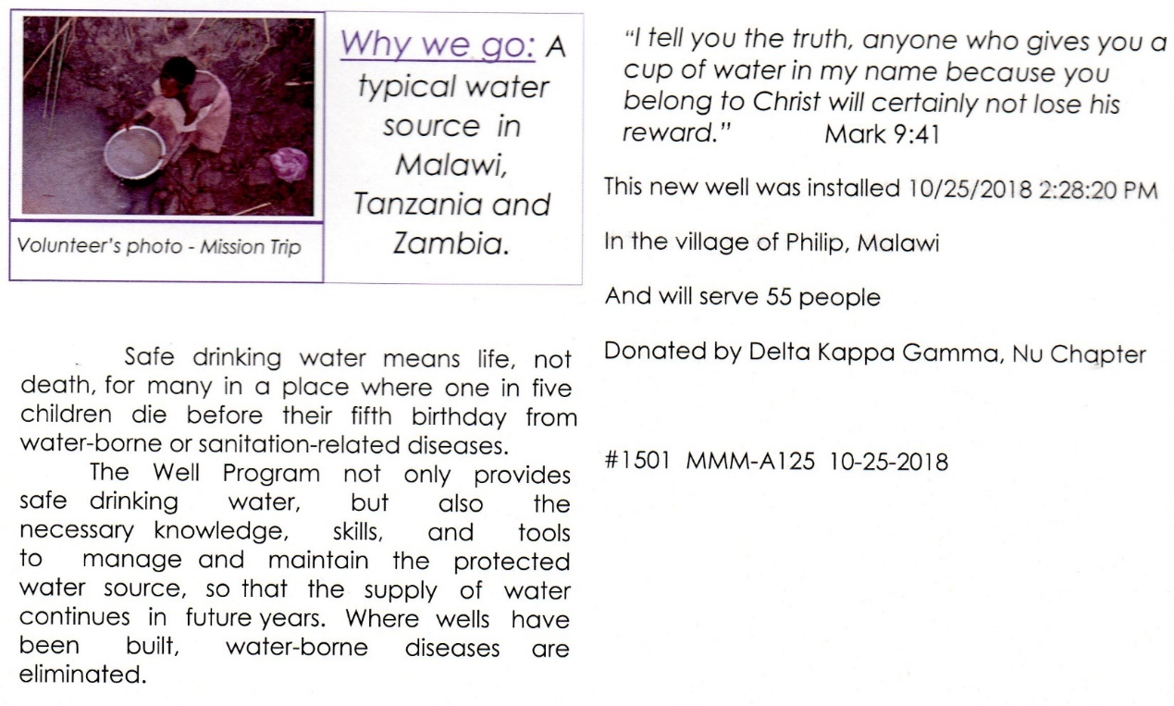

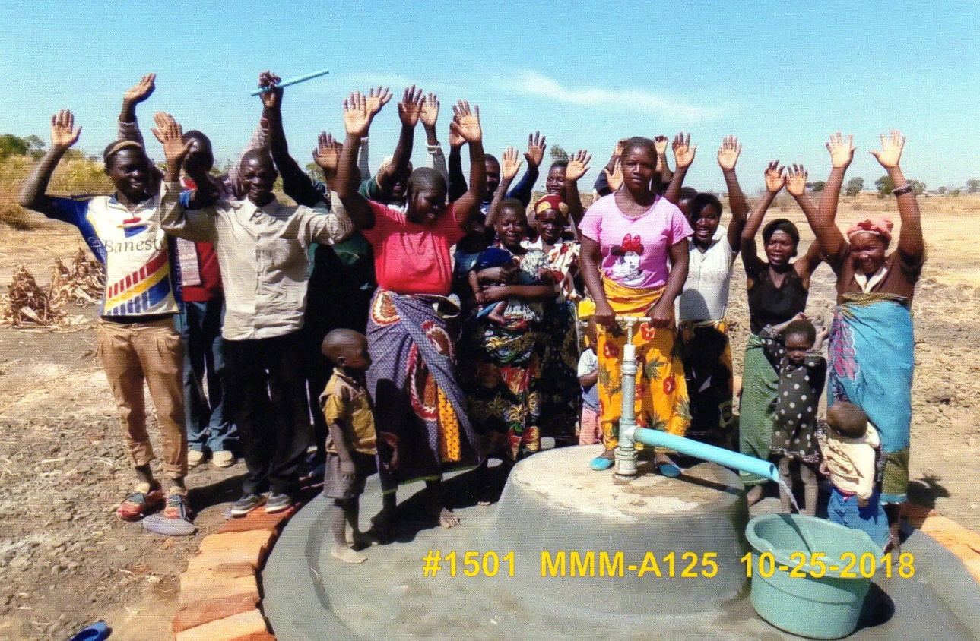

Nu Chapter Rules – A Preview
Chris Berto, Chapter Rules Chair

The Spring Newscaster contains 21 pages of proposed amendments to the state Bylaws and Standing Rules being considered at state convention April 27. If passed, some will affect Nu Chapter Rules. A number of these were addressed in October Nu’s Notes. The Rules Committee will propose amendments to bring Nu Chapter Rules into compliance with the international and state governing documents and those proposed amendments will be published in May Nu’s Notes. Proposed amendments will also be emailed to you immediately following convention so that you may review them prior to voting on them at the May 4th meeting.

A preliminary preview regarding possible amendments to Nu Chapter Rules appears in italics:

To comply with the Constitution, International Standing Rules, state Bylaws and Standing Rules:
•If Illinois State Organization is approved at state convention, this name will replace Lambda State throughout chapter rules (with the exception of reference to Lambda State Achievement Award that will not be renamed).
•Induction and inductee will replace initiation and initiate throughout chapter rules.
•Reference to Collegiate membership will inserted in the proper places in chapter rules.

III. Finances
•New dues structure at International and state level necessitates that chapter dues and assessments shall be approved at the May meeting (strike September), dues will be paid by June 30 (strike October 31), and the budget will be approved by the chapter at the May meeting (strike September).

IV. Officers and Committees
•Treasurer’s duties will include: maintain an accurate and current membership roster.
•Recording Secretary’s duties will include: record in the chapter minutes the names of members terminated, including the reason and date of termination.
•Change Communications and Publicity to Communications and Marketing.

V. Meetings
Will include:
•All members being notified, chapter meetings may be face-to-face, through electronic communications, or through a combination of the two, as long as members present may simultaneously hear one another and participate during the meeting.
•Ratification of all voting by mail (postal or electronic) must be made at the next face-to-face meeting of the chapter.

VI. Executive Board
Will include:
•All members being notified, board meetings may be face-to-face, through electronic communications, or through a combination of the two, as long as members present may simultaneously hear one another and participate during the meeting.
•Ratification of all voting by mail (postal or electronic) must be made at the next meeting.

IX. Member Responsibilities
• Termination of membership for nonpayment of dues will be occur October 1 (strike October 31).

